THE OHIO MUSIC TEACHERS ASSOCIATION PRESENTS
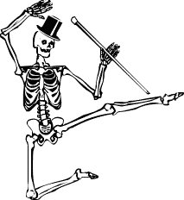
2018 MASQUERADE MUSICALE
Saturday and Sunday, October 27 and 28
Barnes & Noble on the Levee – 1 Levee Way, Newport KY

The Masquerade Musicale is an informal performance opportunity held the weekend before Halloween for instrumental and vocal students through grade 12. This is a great time to show off your Halloween costume and get in the “spirit” of the season! Teachers register students for this event. Entry fee is $15 per student ($20 for non-OMTA members). Fees are non-refundable. Any student requiring accompaniment should bring an accompanist.
Each student or ensemble may perform a maximum of three minutes of music. Memorization is optional – no illegal photocopies, please. Ensemble numbers count as one entry. Recitals will take place hourly, each lasting 30 – 45 minutes. We respectfully request that performers stay for their entire recital. Each performer will receive a treat after playing.
Performance schedules will be available to your teacher about one week before the event.

Student Checklist for Masquerade Musicale
___ Early September: Decide what to play for Masquerade Musicale
___ Late September: Give your teacher the information for your piece, along with $15 entry fee. (Non–OMTA member fee is $20 per student). Make checks payable to OhioMTA Southwest.
___ Early October: Make arrangements for an accompanist, if needed.
___ About a week before the event: Your teacher will receive the performance schedule and notify you.
___ On performance day: Arrive at Barnes & Noble 10-15 minutes before your recital time. Allow plenty of time for parking and getting to the bookstore. Perform your piece wearing your Halloween costume, and enjoy listening to the other participants!

